Adrien Protzel

1. 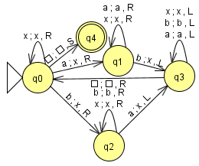

$a^{n}b^{n}, n≥0$

Start at q0, move to q1 or q2 if input is a or b respectively and change the a or b to an x, move right in either case. Otherwise, move right on any x.

In either states q1 or q2, bypass a\b and x by moving right until; b is reached from q1; a is reached from q2. Move left in both cases to q3.

In q3, loop left until blank is reached, then move right at q0.

In q0, move right on any x until an a or b is reached and repeat the loops on q1 and q2 to q3 to q0.

If all x’s are passed and the tape reaches a blank, move to q4 and succeed.

* 1. 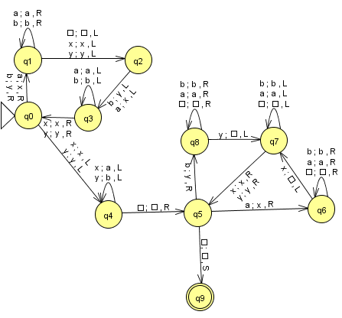ww

Start at q0, move to q1 on input a or b, change to x or y respectively, move right in both.

In q1, loop right on all a and b inputs until x, y, or blank is reached, then move left to q2.

In q2, the head will be on a letter a or b because the left from q1 moves. So change a or b to x or y respectively and move left, move to q3.

In q3 move left on all a\b inputs until x or y is reached, then move right to q0. Continue the q0->q1->q2->q3->q0 loop until the whole string is x or y then move to q4.

In q0, if input is x or y, then that means there are no a or b in the string left, move left to q4.

In q4, move left on x and y inputs and change them to a and b respectively, until blank is reached. Move right to q5.

In q5, move to q6 if input is a (change to x) (move right). Move to q8 if input is b (change to y) (move right).

In both q6 and q8, move right on any a, b, blank inputs. If in q6 and x is input, move to left and to q7. If in q8 and y input, move left and to q7.

From q7, loop left on all a, b, blank inputs and move to q5 on input x or y (move right).

From q5, move to q9 if blank input and succeed.

1. 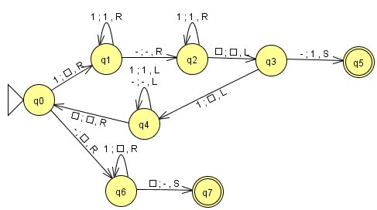
   1. Q0:

Input: 1, change to blank, move right, move to q1.

Input: -, change to blank, move right, move to q6.

Q1:

Input: 1, move right, loop

Input: -. Move left, move to q2

Q2:

Input: 1, move right, loop

Input: blank. Move left, move to q3

Q3:

Input: -, change to 1, move to q5

Input: i. Change to blank, move left, move to q4

Q4:

Input: -, move left, loop

Input: 1, move left, loop

Input: blank. Move right, move to q0

Q5:

Succeed

Q6:

Input: 1, change to blank, move right, loop

Input: blank. change to -, move to q7

Q7:

Succeed

* 1. 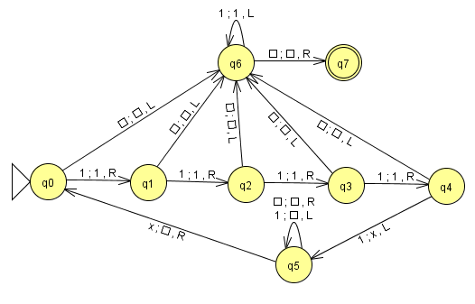Q0:

Input: 1, move right, move to q1.

Input: blank, move left, move to q6.

Q1:

Input: 1, move right, move to q2.

Input: blank, move left, move to q6.

Q2:

Input: 1, move right, move to q3.

Input: blank, move left, move to q6.

Q3:

Input: 1, move right, move to q4.

Input: blank, move left, move to q6.

Q4:

Input: 1, change to x, move left, move to q5.

Input: blank, move left, move to q6.

Q5:

Input: 1, change to blank, move left, loop.

Input: blank, move right, loop.

Input: x, change to blank, move right, move to q0.

Q6:

Input: 1, move left, loop.

Input: blank, move right, move to q7.

Q7:

Succeed